**DAILY ONLINE ACTIVITIES SUMMARY**

|  |  |  |  |  |  |  |
| --- | --- | --- | --- | --- | --- | --- |
| **Date:** | **23/05/2020** | | | **Name:** | **JASLINE SHARON TAURO** | |
| **Sem & Sec** | **4th sem, A Section** | | | **USN:** | **4AL18CS029** | |
| **Online Test Summary** | | | | | | |
| **Subject** | | **DATA COMMUNICATION** | | | | |
| **Max. Marks** | | **30** | | **Score** | **25** | |
| **Certification Course Summary** | | | | | | |
| **Course** | 1. **STEPathon-communication skills [ICT ACEDAMY]** | | | | | |
| **Certificate Provider** | | | **1.THE HINDU** | **Duration:**  **2 hrs.** | |  |
| **Coding Challenges** | | | | | | |
| **Problem Statement:** Write a C Program to generate first N Triangular Numbers (Where N is Read from the Key board) | | | | | | |
| **Status: DONE** | | | | | | |
| **Uploaded the report in GitHub** | | | | **YES** | | |
| **If yes Repository name** | | | | [**https://github.com/jaslinesharontauro/C_Prgms**](https://github.com/jaslinesharontauro/C_Prgms) | | |
| **Uploaded the report in slack** | | | | **YES** | | |

**Online Test Details: (Attach the snapshot and briefly write the report for the same)**

**Certification Course Details: (Attach the snapshot and briefly write the report for the same)**

**Coding Challenges Details: (Attach the snapshot and briefly write the report for the same)**

**1.ONLINE TEST DETAILS:**

**Today we had assessment in the subject DATA COMMUNICATION. It was based on first module of this subject. There were total 30 number of questions of ONE mark each.**

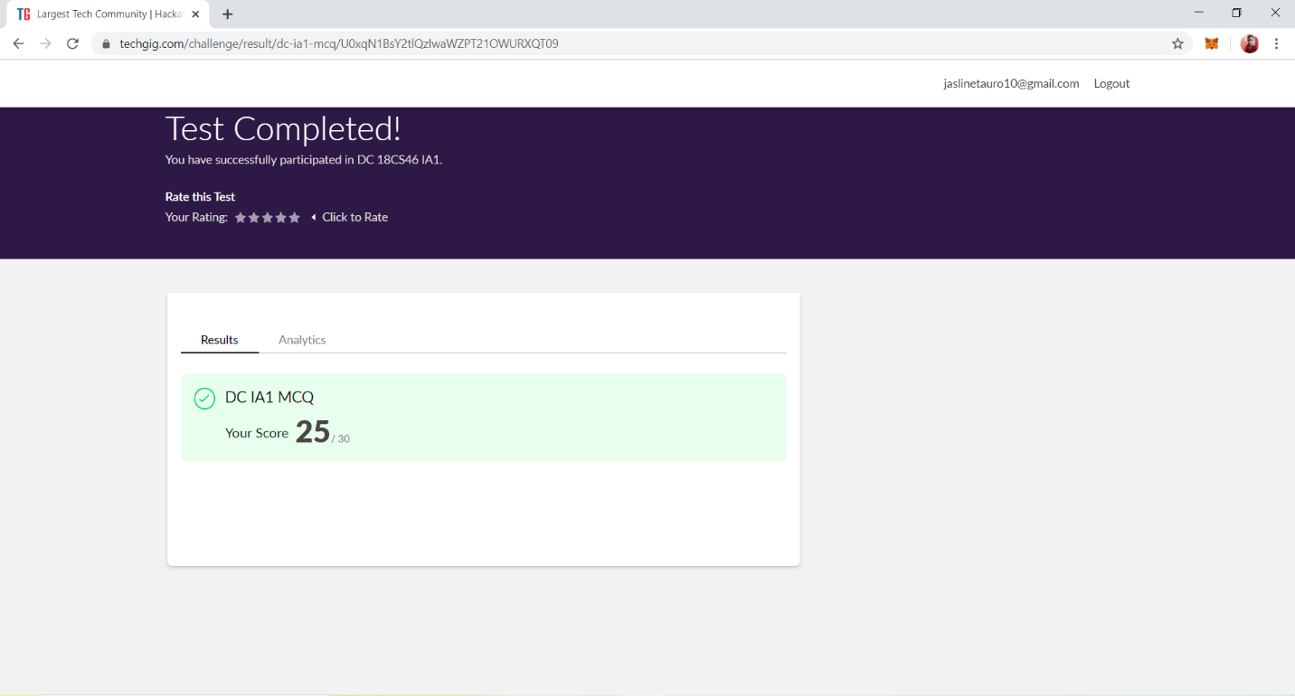

**2.CERTIFICATION COURSE DETAILS**

I have done certification course on communication skills i.e, “THE STEPathon9” by The Hindu group. This course has a series of video-based webisodes or lessons which form an exciting story about a group of friends as they take a trip across India. Each webisode focuses on various language skills like reading, writing, listening, speaking, grammar, vocabulary.

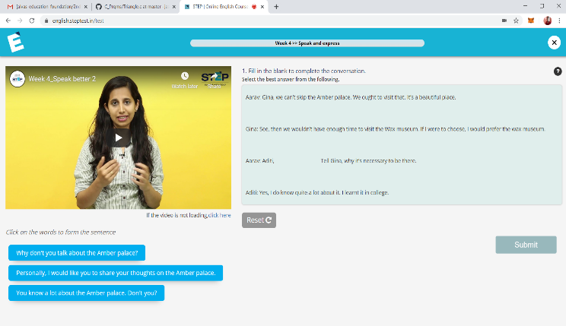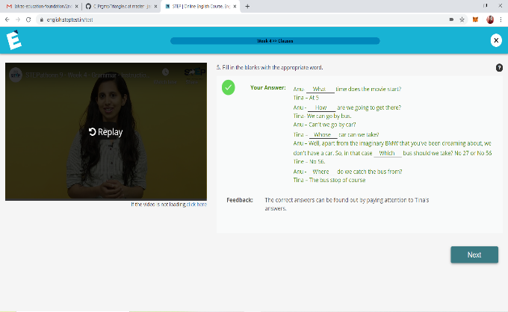

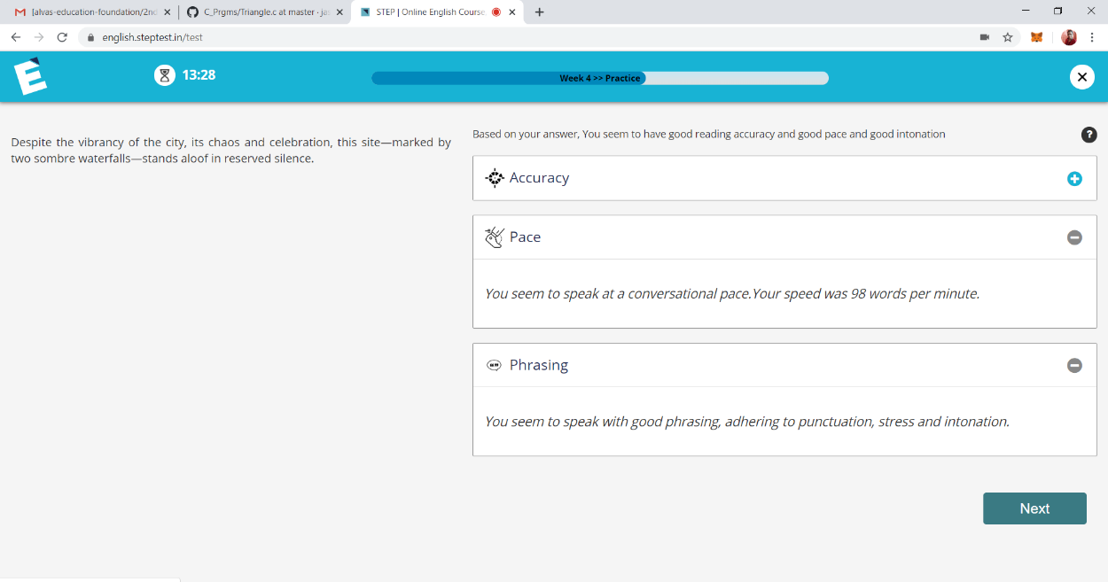

**3.CODING CHALLENGES DETAILS:**

**Problem statement 1:**

Write a C Program to generate first N Triangular Numbers (Where N is Read from the Key board)

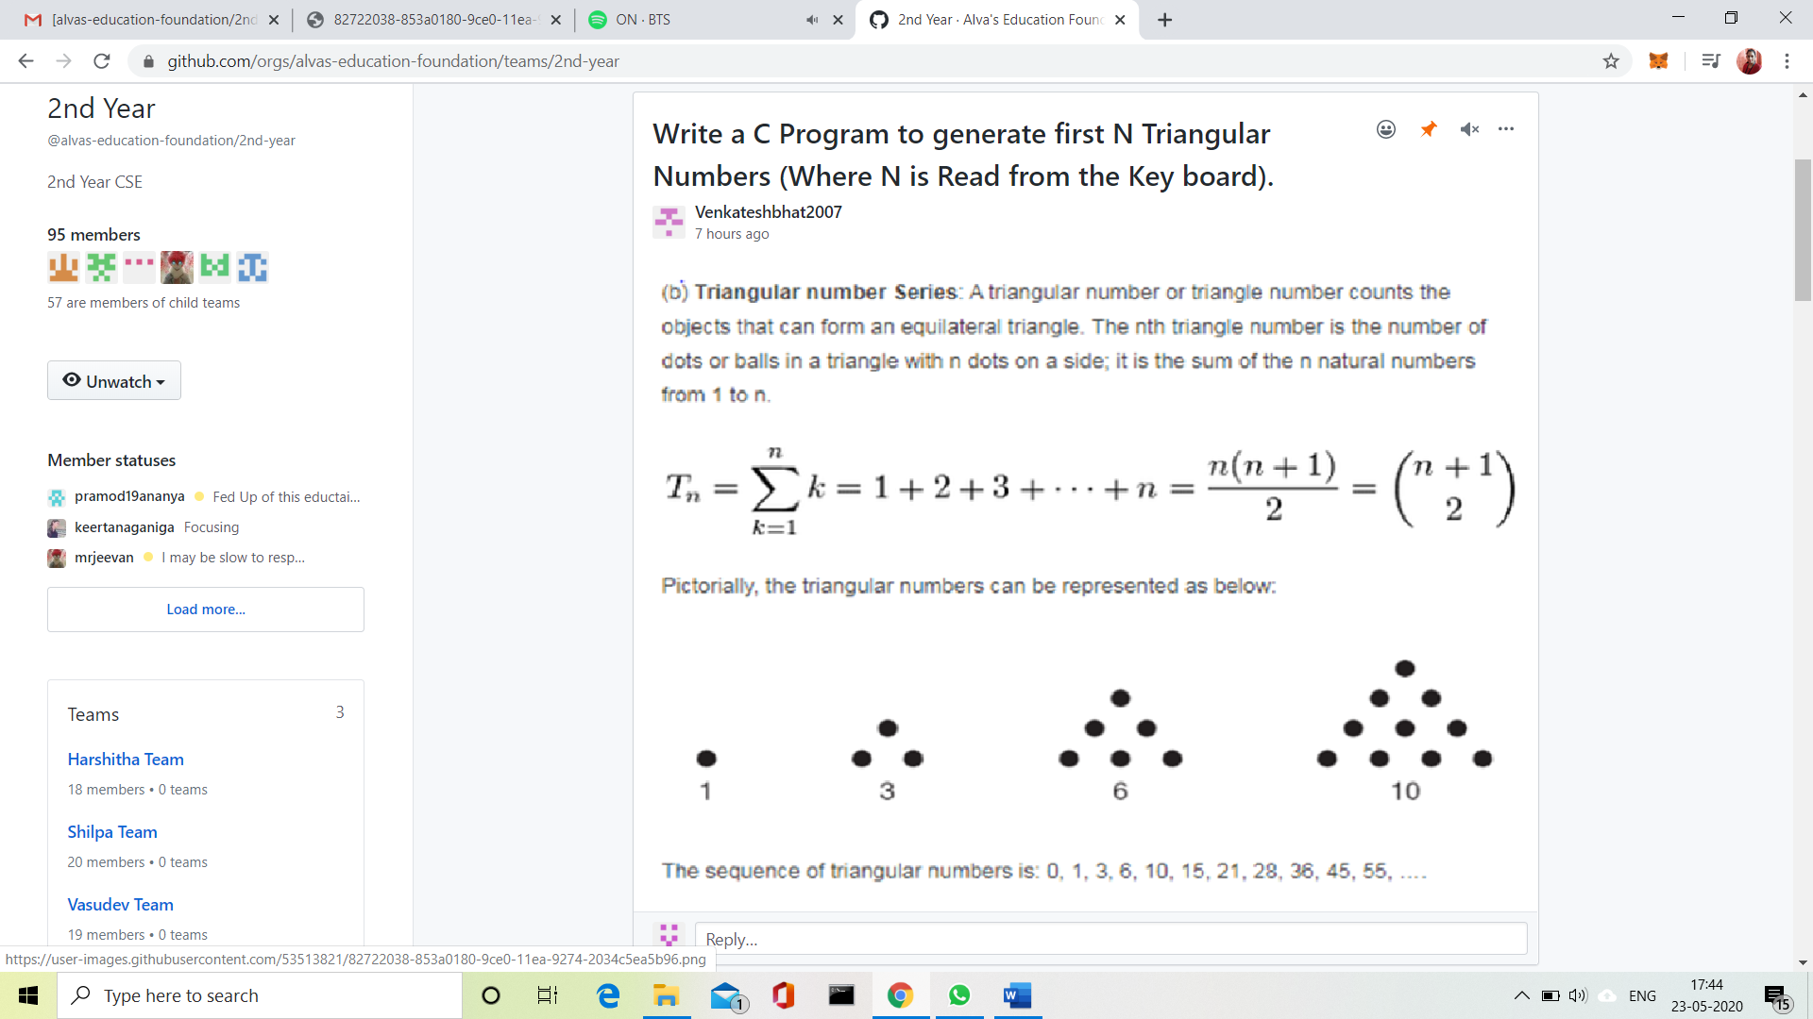

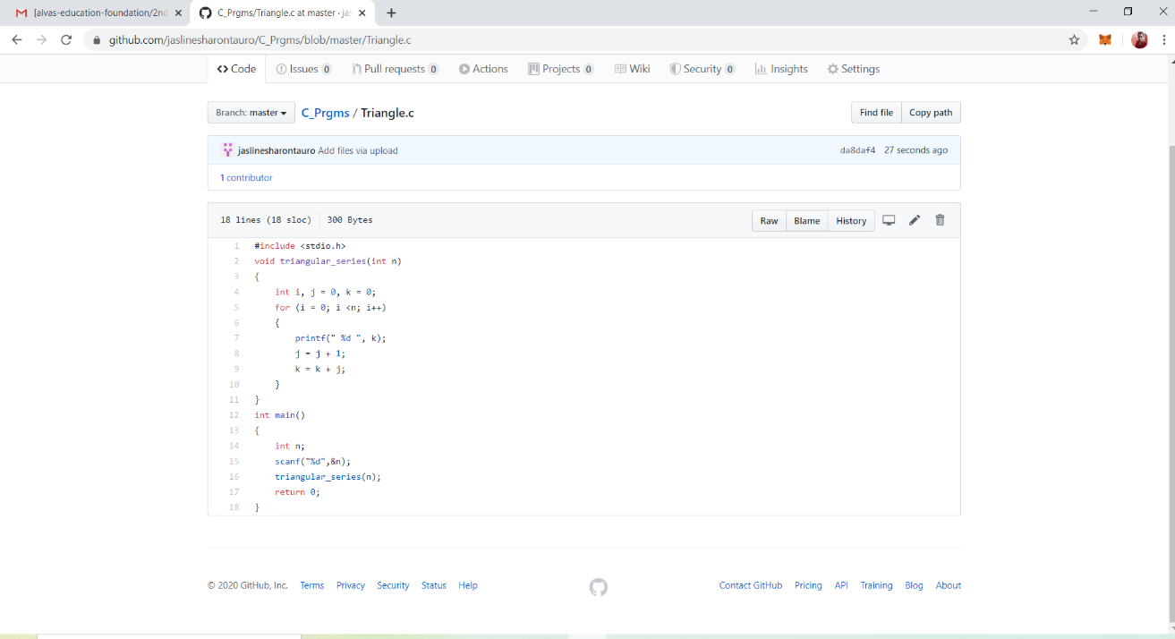**Solution: Uploaded it in GitHub**